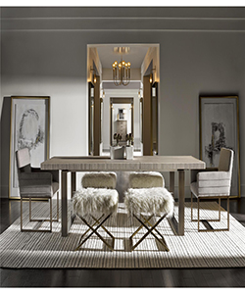

Dining Table

$375.57

Availability: In stock

Description

This collection of Dining table geometric appeal, it is perfect for casual or formal settings. The combination of material, Contemporizes style and Quartz finish make this Dining table unforgettable.